SE212 Database System and Design — Software Engineering Department

Lab 5-2 (Version B): ERD Modeling and Logical Mapping
Duration: 2 hours · Submit to Mango under the lab section

Introduction
Two stages: draw an ER/EER diagram in Draw.io, then convert it into relations using the mapping algorithm.
** Make sure that your tables are in 1st normal form **
Submit: one Draw.io file (page 1 = ER diagram, page 2 = relational schema) plus this worksheet as PDF.

The Problem
Ms. Naree has taken over Lanna Skills Academy, a vocational training school in Chiang Mai offer-ing short courses in barista skills, Thai massage, photography, and programming. The academy runs three campuses: Nimmanhaemin, Hang Dong, and San Kamphaeng. It currently keeps ev-erything in paper files and a shared spreadsheet. She has hired you to design a database that tracks enrolments, students, and instructors. After an initial meeting, you have developed the following business rules.
- Students enroll through a campus.
- Track about students: Name, Address, District, Province, Postcode, Telephone, Date of Birth, and Nationality.
- A student may make many enrollments over time.
- A student does not always have to enroll through the same campus.
- Students may hold one or more scholarship awards, although they may also hold none.
- Record about scholarships: Award Date, Amount, Sponsor Name, and Award Type.
- A campus may have many students.
- Record about each campus: Campus Code, Location (Address, District, Province, Postcode), and Number of Classrooms.
- A campus may offer all courses or may only offer certain courses.
- An enrollment covers one or more courses.
- Record about each enrollment: Enrollment Date and Payment Status.
- A course may be offered at one or more campuses.
- Record about each course: Title, Level, Duration in Hours, Standard Fee, and Category.
- A course may require other courses as prerequisites; for example, Advanced Latte Art (course 40) requires Basic Espresso (course 12) and Milk Steaming (course 15).
- Ms. Naree employs 60 instructors across the three campuses.
- Track about instructors: Name, Address (Street, District, Province, Postcode), Telephone, Date of Hire, Position, Salary, Qualification, and Age.
- Each instructor is based at one and only one campus.
- Each instructor may have one or more dependents. Record the name of the dependent, the age, and the relationship.
- Instructors may hold one or more qualifications.

Part 1 — Assumptions (10 marks) · 10 min
The rules are incomplete. Fill in the second column.

# Gap in the rules Your assumption

1 No identifier is given for
STUDENT
2 No identifiers for
SCHOLARSHIP, ENROLLMENT,
COURSE, INSTRUCTOR

3 Rule 10 does not say whether
the fee actually charged is recorded per course on an enrollment
4 Rule 16 records instructor
Age; Rule 2 records student Date of Birth

5 Rule 5 does not say whether a
scholarship can be shared by more than one student
Example: introduce
student_id as a surrogate PK
scholarship_id as a PK for SCHOLARSHIP
enrollment_record_id as a PK for ENROLLMENT
course_code as a PK for COURSE
instructor_id as a PK for INSTRUCTOR
Enrollment record total fees derived from sum of standard fees of each enrolled Course

To keep the consistency and relevance of data, we should also record Date of Birth in Instructor , and making Age attribute derived attribute in both Instructor and Student

From my experience, I’ll assume that one scholarship only belongs to one student.

No single correct answer. You are graded on whether each assumption is stated, rea-sonable, and applied consistently in both your diagram and your relations.

Part 2 — ER Diagram (40 marks) · 45 min

Entities and attributes

Entity type | Primary key | Strong / Weak | Any composite, multivalued, or derived attributes?
Students | student_id | Strong | name, address, district, province, postcode, tel, birthdate, age (derived), and nationality
Campus | campus_code | Strong | location (Composite composed of address, district, province, and postcode), and number_of_classrooms.
Course | course_code | Strong | title, level, hours_duration, standard_fee, and category
Instructor | instructor_id | Strong | name, address (Composite composed of street, district, province, and postcode), tel, hiredate, birthdate, position, salary, qualification (multivalued), and age (derived).
Dependent | name (partial) | Weak | age, relationship
Scholarship | scholarship_id | Strong | award_date, amount, sponsor_name, and award_type.

Relationships

Relationship Entities Cardinality
Participation (each side)
Relationship attributes

Relationship | Entities | Cardinality | Participation (each side) | Relationship attributes
Enroll | Student, Course | Many-to-many | Student: Optional many (A course may not have any student enrolled in, hence close the course)  Course: Mandatory many (Student enrolls in many courses) | enrollment_record_id, enroll_date, payment_status, total_payment (derived)  FKs  student_id  course_code
Award | Student, Scholarship | One-to-many | Student: Mandatory one (One scholarship, one student)  Scholarship: Optional many (Student may or may not be awarded at least a scholarship) | -
Require | Course | Many-to-Many | Course: Optional many (A course may have or may have not any prerequisite, while a course can be a prerequisite to other courses, but it doesn’t have to be) | -
Is based at | Instructor, Campus | One-to-many | Instructor: Mandatory many (Campus should have at least one instructor.)  Campus: Mandatory one (Instructor only based at one campus) | -
Offer | Campus, Course | Many-to-many | Campus: Mandatory many  Course: Mandatory many | -
Have | Instructor, Dependent | One-to-many | Instructor: Mandatory one (Dependent depends on one Instructor)  Dependent: Mandatory many (Instructor has at least one dependent) | -

Three questions
- Rule 14 describes a course requiring other courses. What is this kind of relationship called, what is its cardinality, and what two role names will you label?
Your answer: Unary relationship. The cardinality is many-to-many
- Why is DEPENDENT a weak entity type? Give its owner, its identifying relationship, and its partial key.
Your answer: Because without an instructor, dependents have no role involved in the system at all. It needs to solely rely on Instructor to identify itself. The identifying relationship is “Has/Have” and the partial key is “name”
- Rules 1 and 4 mean an enrollment connects a student, a campus, and one or more courses. Should this be one ternary relationship or two binary relationships plus an entity? Justify.
Your answer: Two binary relationships obviously (Student ––< Enroll >–– Course), as students will enroll in multiple courses. Although, since a course is offered by a campus, you do not need to link the relationship with Campus, as the campus is already linked to the course through Offer relationship (Campus –– <Offer>–– Course). The course data is already on the course, and rule 4 enables students to enroll across different campuses, which testifies that there is no need for the Campus link.

Draw it
Draw the diagram in Draw.io using Chen notation.
□~Every entity has an underlined PK □~DEPENDENT = double rectangle + double diamond + dashed-underlined partial key □~Every line labelled 1, M, or N; total participation = double line
□~Recursive relationship on COURSE has both roles labelled □~Multivalued = double oval, de-rived = dashed oval, composite = child ovals
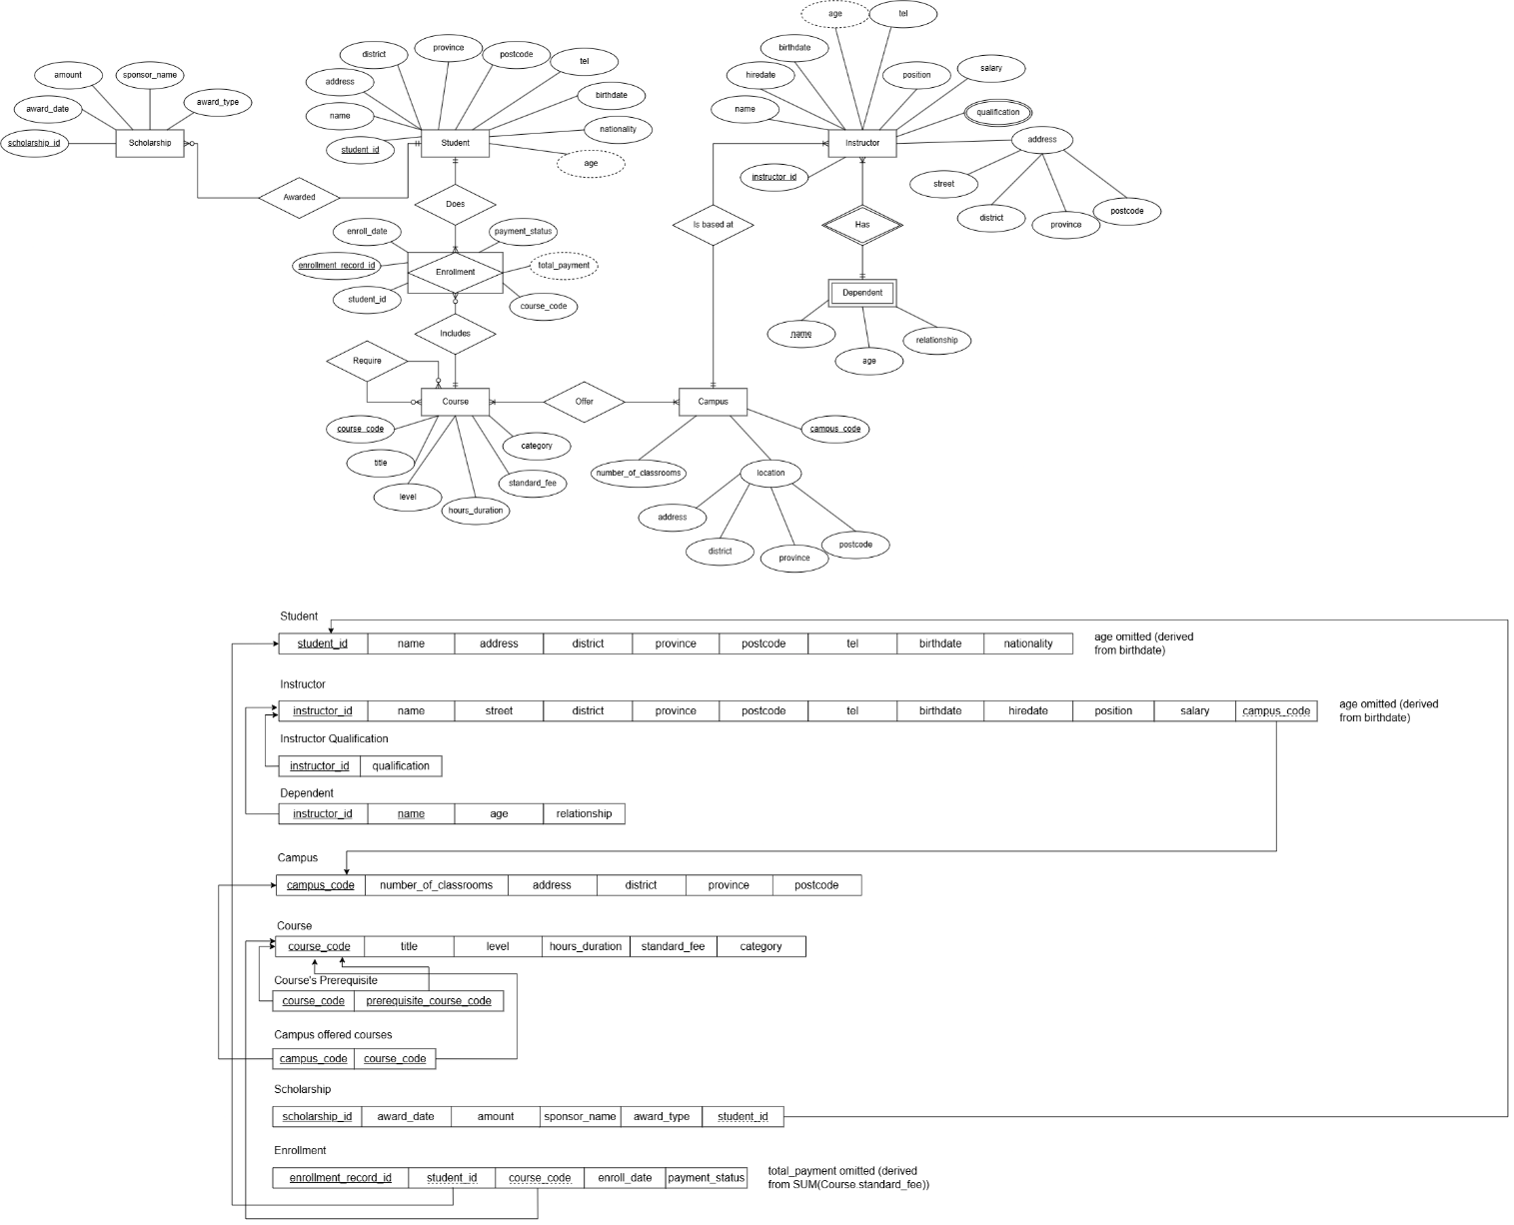

Part 3 — Mapping to Relations (40 marks) · 45 min
Apply the steps in order. Later steps use keys from earlier ones.

Format and worked example (given to you)
Step 1 — regular entity CAMPUS. The composite Location is flattened, because a relational attribute must be atomic:
CAMPUS(campus_code, address, district, province, postcode, num_classrooms) PK: campus_code
Step 6 — a multivalued attribute cannot be a column (that breaks 1NF), so it becomes its own relation:
CAMPUS_PHONE(campus_code, phone_no) PK: (campus_code, phone_no)
FK: campus_code → CAMPUS(campus_code)
Use this format throughout.

Step 1 — Regular (strong) entity types. Flatten composites. Omit derived and multivalued attributes; note where you did.

Step 2 — Weak entity type. Owner’s PK + partial key = composite PK.
Step 3 — Binary 1:1. If none, write “none” and say why.

Your answer: None. There are not any one-to-one relationships drawn in ER diagram and stated in the business rule.
Step 4 — Binary 1:N. Post the PK of the “1” side into the “N” side as a FK. Mark each FK NOT NULL where the N side has total participation.

Step 5 — Binary M:N. Each becomes a new relation: both FKs form the PK, plus any relationship attributes.
⚠ One of these is recursive — both FKs point at the same relation, so the two columns must have different names.

Step 6 — Multivalued attributes.

Step 7 — N-ary relationships. If none, refer back to your answer in 2.3(c).
Your answer:

Total number of relations: 10

Schema diagram
On page 2 of your Draw.io file, draw each relation as a box and an arrow from every FK to the PK it references.
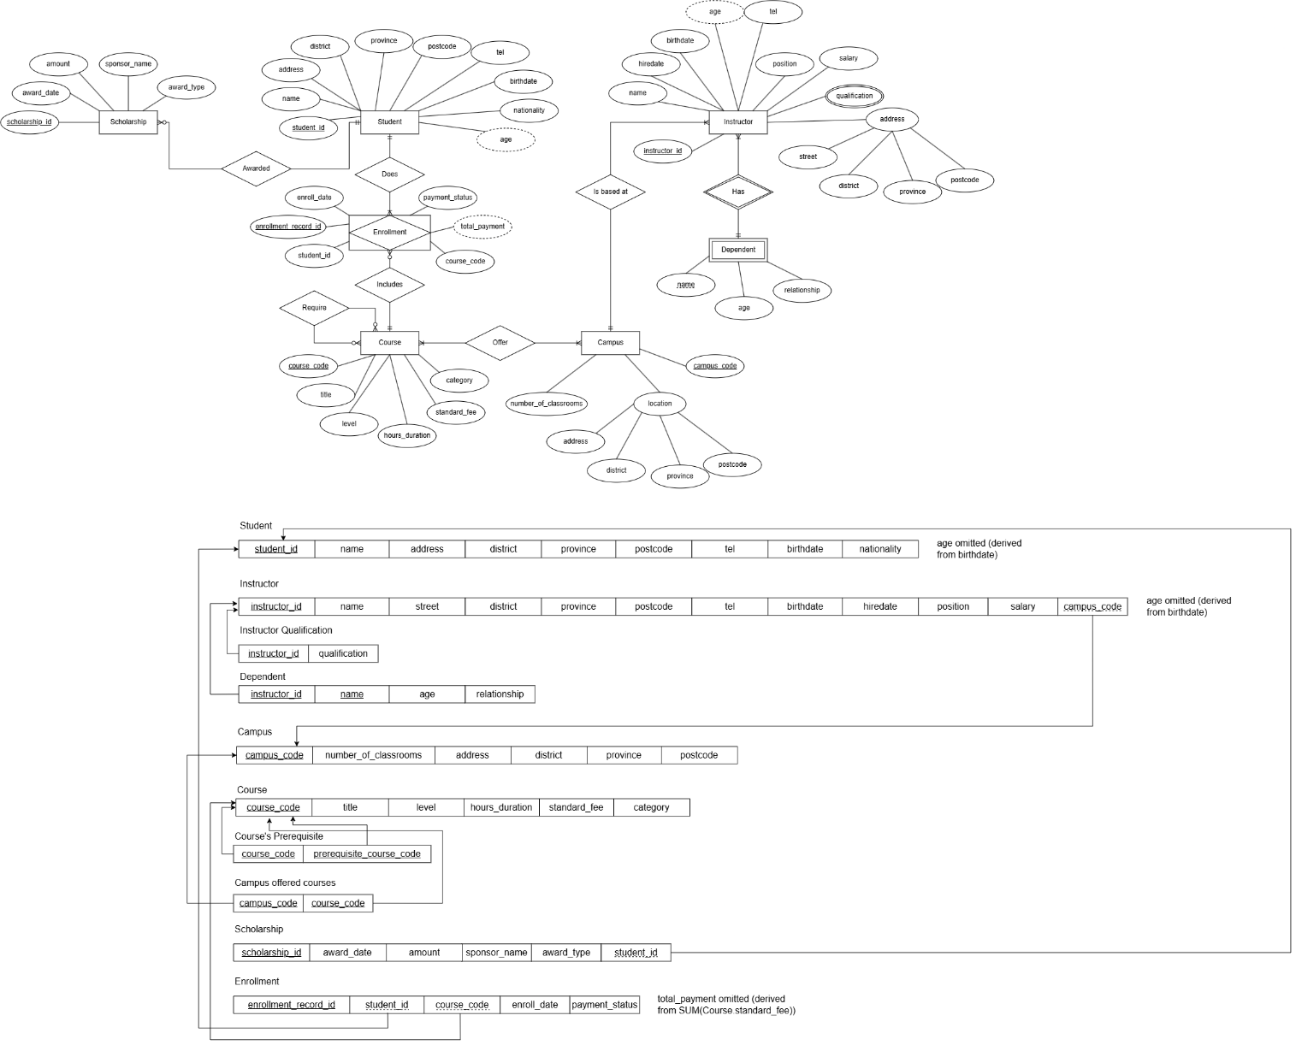

Part 4 — Check Your Work (10 marks) · 15 min
  - Where did each of these end up, and why?

Attribute | Which relation now? | Why it could not stay where it started
Instructor Qualification | Instructor Qualification | Actually, it could, but that is not practical when dealing/querying data later.
Campus Location (Address, District, Province, Postcode) | Campus | It actually stays in the relation/entity it was originally there. You just need to flatten the composite key, and that’s it.

These two are the key contrast of the lab: one needs a new relation, the other only needs flattening. Make sure you can say why.
  - List, in order, the relations you would join to answer:
- “Which courses did student S-2210 enroll in, and at which campus?”
Your answer: Student join Course join Campus OR Find that specific student ID in Enrollment (output 1-to-many rows of course_code), then join it with Course, and Campus.
- “What was the total fee income from all enrollments made in January 2026?” — state which relation holds the fee you would use, and why the other candidate would give a wrong answer.
Your answer: Enrollment which that attribute will derive from standard_fee of all the courses the student enrolled in. Other relations (Student / Course) cannot have derived that data because of insufficient data (Course already have standard_fee of its own, and Student cannot access Course without through Enrollment)

Marking Rubric

Criterion Marks
Assumptions stated and consistently applied 10
Entities, keys, attribute classification 12
Relationships: cardinality and participation 12

Criterion | Marks
Weak entity and recursive relationship drawn correctly | 10
Diagram completeness and notation | 6
Mapping Steps 1–2 | 8
Mapping Steps 3–5 (FK placement, M:N relations) | 18
Mapping Steps 6–7 and schema diagram | 14
Part 4 | 10
Total | 100

Submission Checklist
□~Draw.io file: page 1 = ER diagram, page 2 = relational schema □~Worksheet com-pleted, exported as PDF □~Assumptions in Part 1 match what you actually drew □~Filename: SE212_Lab5-2_<studentID>_<name> □~Uploaded to Mango before the deadline

Homework (not marked in this lab)
Ms. Naree adds two rules. Extend your diagram and say how each maps to relations.
- Every instructor is exactly one of: a full-time lecturer, a part-time lecturer, or a workshop assistant — never two, and no other kind.
- Separately, some instructors are curriculum reviewers and some are student counsellors. An instructor may be both, either, or neither.
Which mapping option works for the first rule but not the second, and why?

